- Top 10 hub notes:
Protein | Degree
ZRANB1 | 4160
PARK2 | 3426
EGFR | 3070
PLEKHA4 | 2971
KIAA1429 | 2932
KRAS | 2891
MYC | 2817
CCNF | 2798
CUL3 | 2656
TRIM25 | 2497

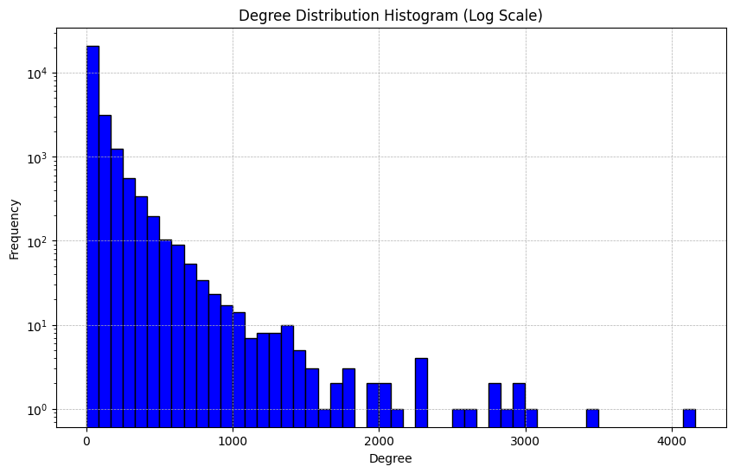

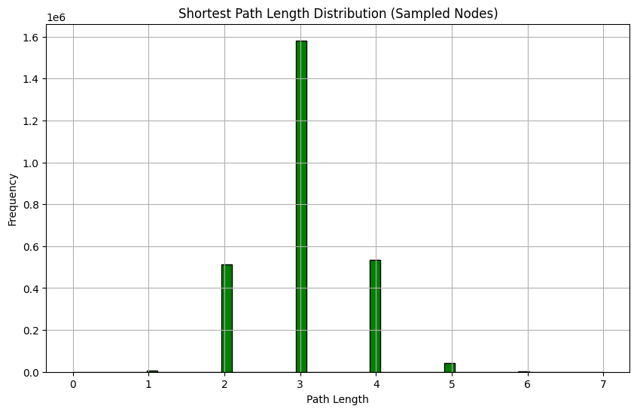

- Top 10 Betweenness Centrality Nodes:

Node | Betweenness
EGFR | 2.841219144517702e-07
ESR2 | 1.6966331776228848e-07
PARK2 | 1.6211047022336272e-07
OTUD4 | 1.56951554906311e-07
NR3C1 | 1.3919409130862165e-07
SPTBN1 | 1.375356067308354e-07
TFCP2 | 1.369384188110651e-07
NOTO | 1.3675573777187747e-07
SMURF1 | 1.279332903332244e-07
VCP | 1.270265511170987e-07

Top 10 Closeness Centrality Nodes:

Node | Closeness
G3BP1 | 0.4438474350944815
PFKL | 0.4159259081276378
ATP6V1A | 0.41292911110386843
USP39 | 0.40847972918907277
BICD2 | 0.40767087075897146
TMED10 | 0.4055335899540469
MED14 | 0.3913952755326368
HIST1H2BD | 0.39015715233967807
ZNF609 | 0.38849213749342787
SARNP | 0.38833994016450085

